**Frontend validation**

Register user

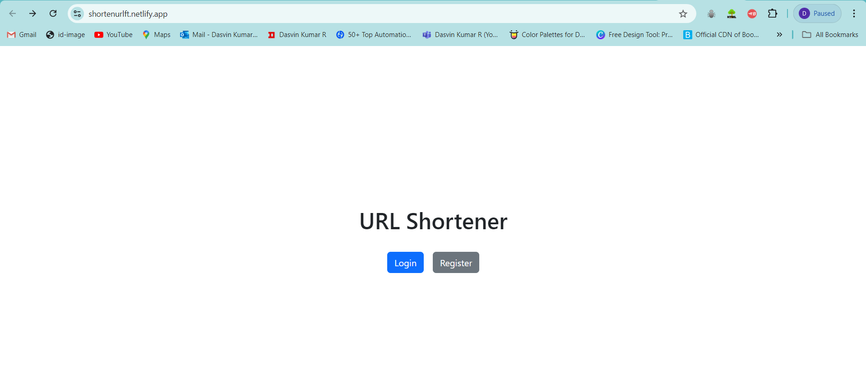

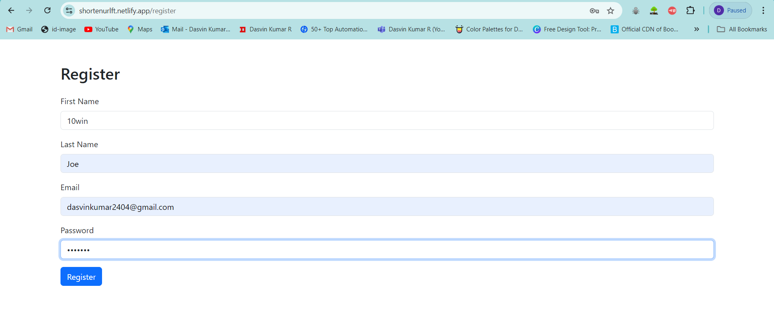

After registration success redirects to login page

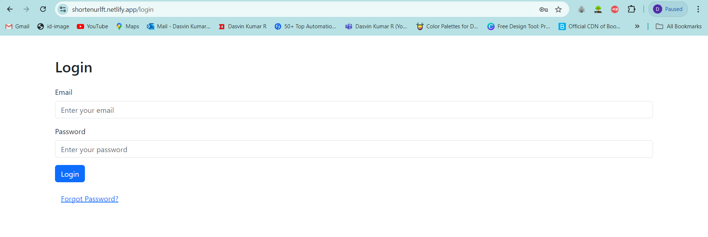

DB check for user registered and account inactive at initial

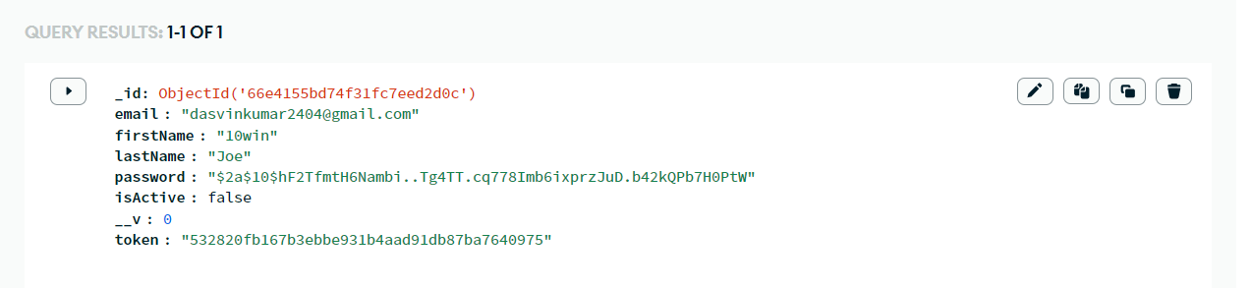

Activation Mail

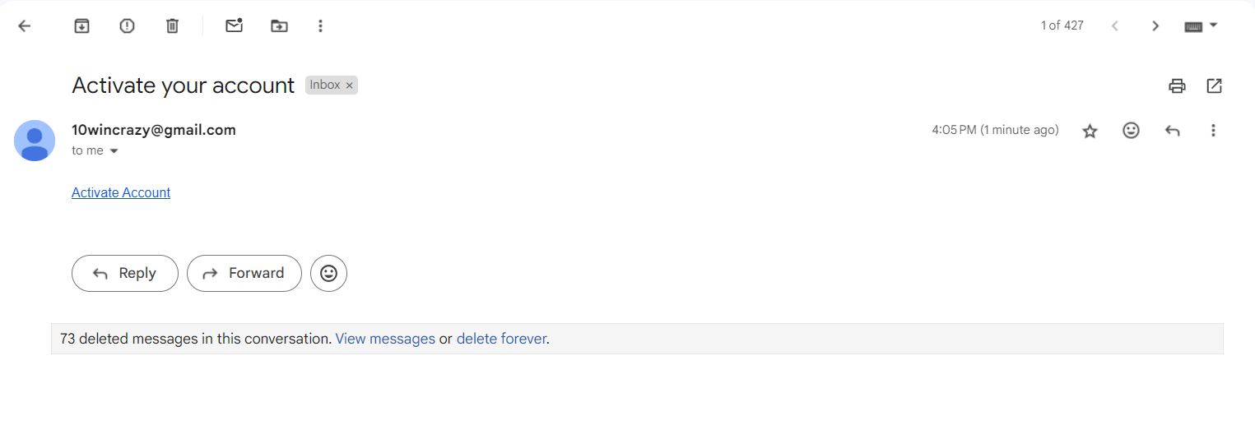

Account activation

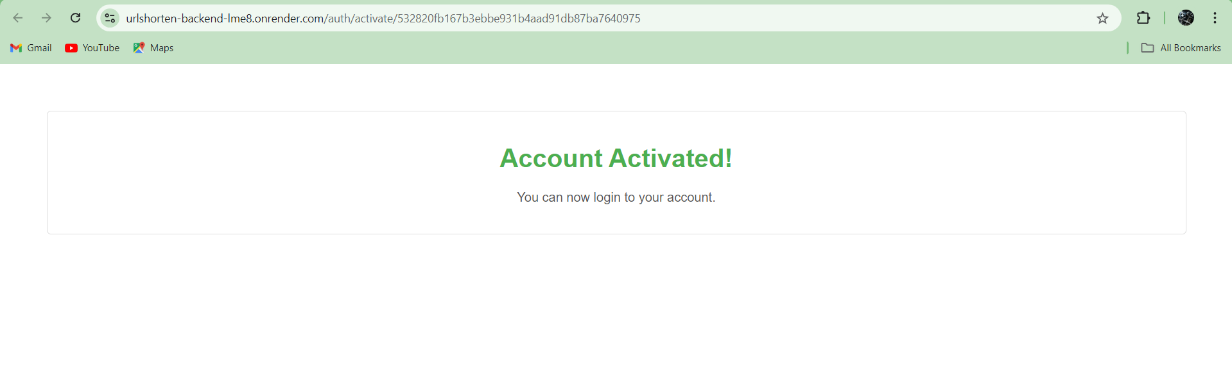

Login with registered user

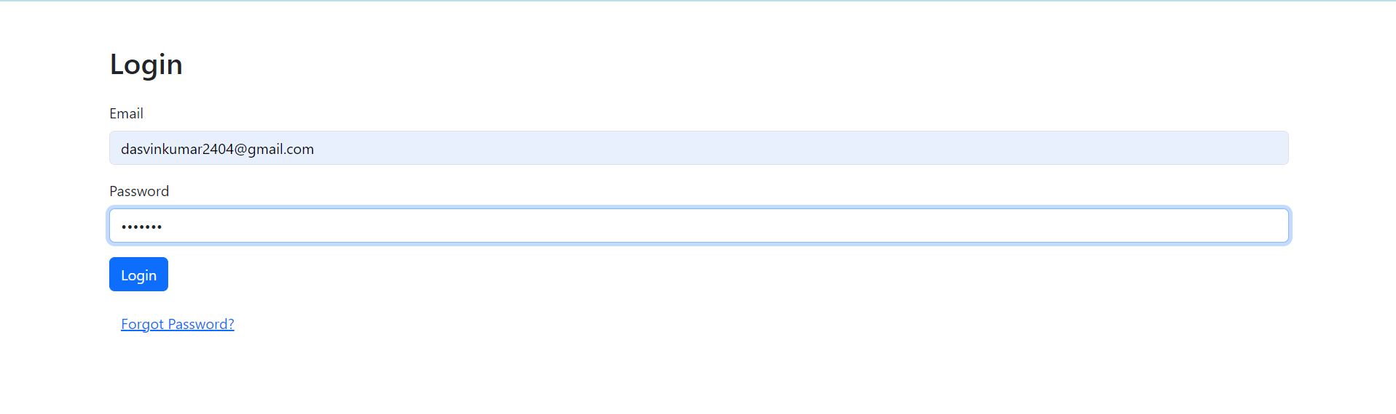

Dashboard after login

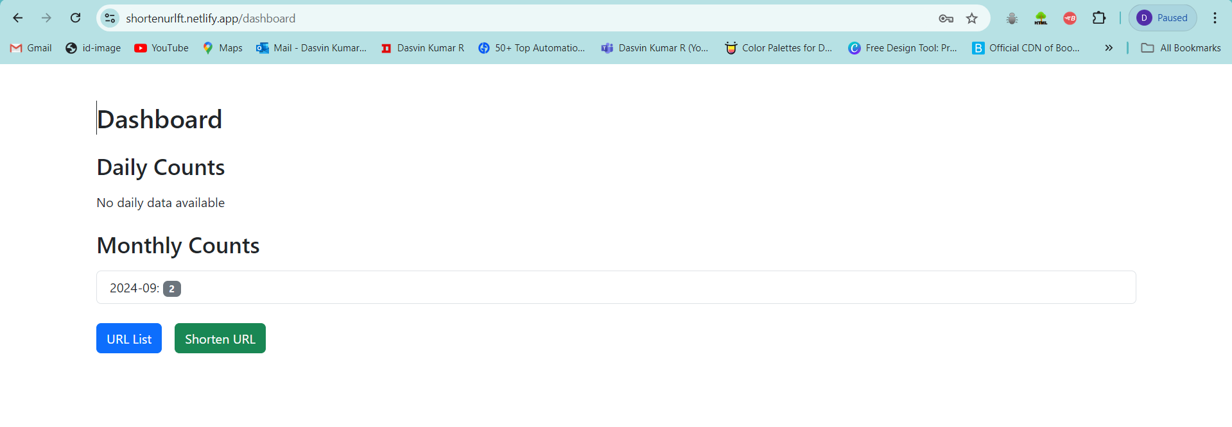

Url list page

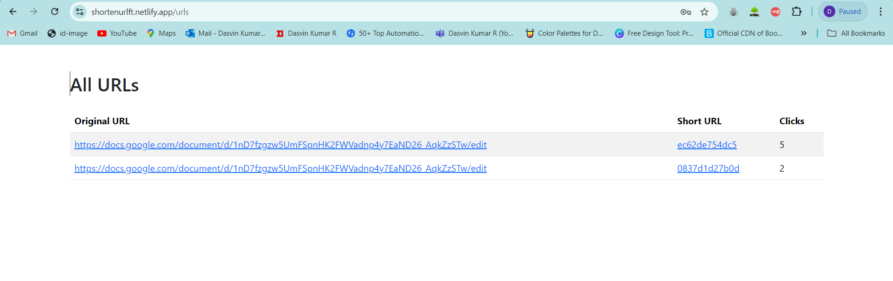

Shorten Url

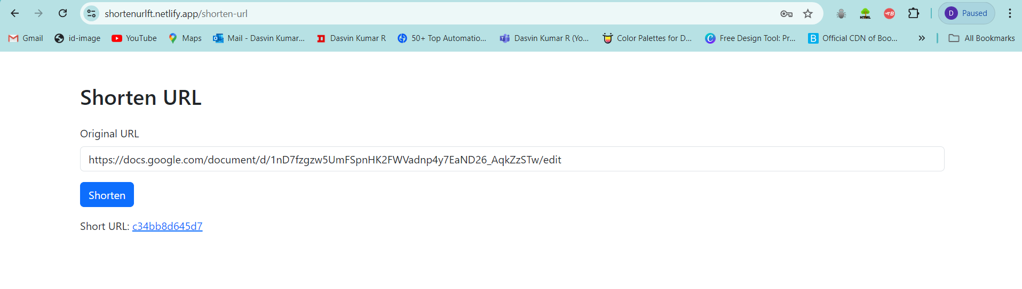

Redirect to original url when shorten url is clicked.

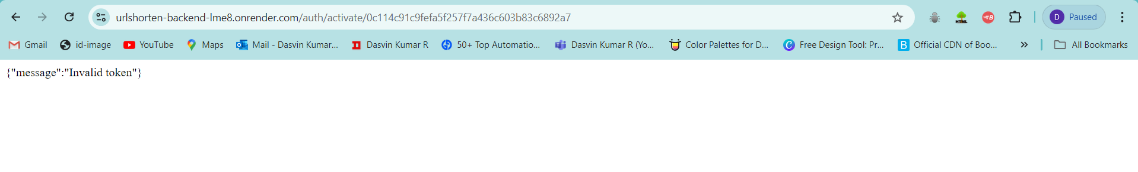

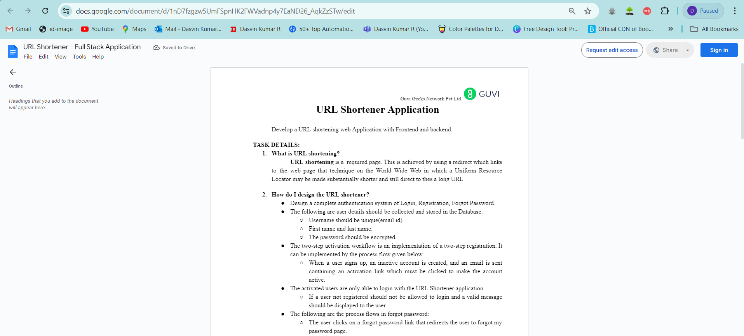

Dashboard after url shorten made.

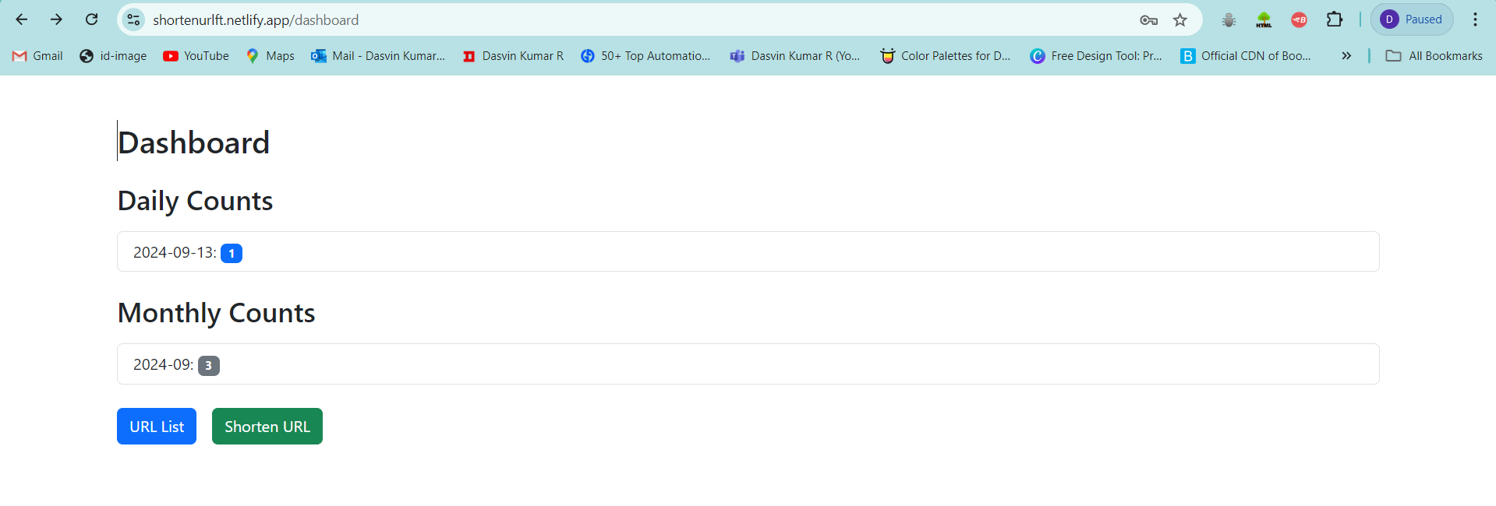

Forgot password flow

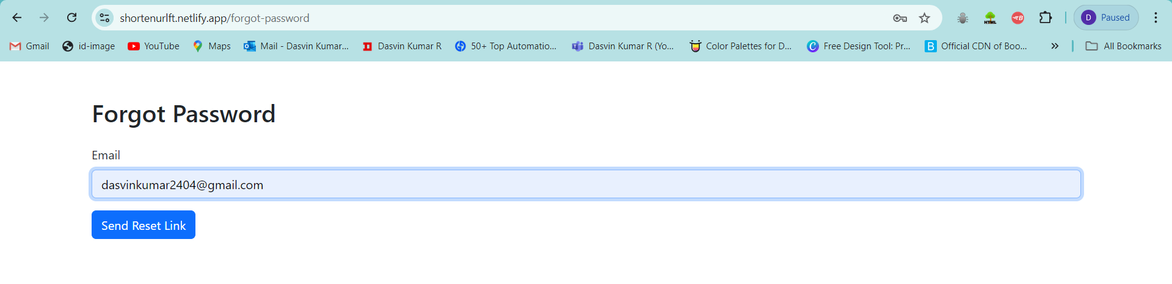

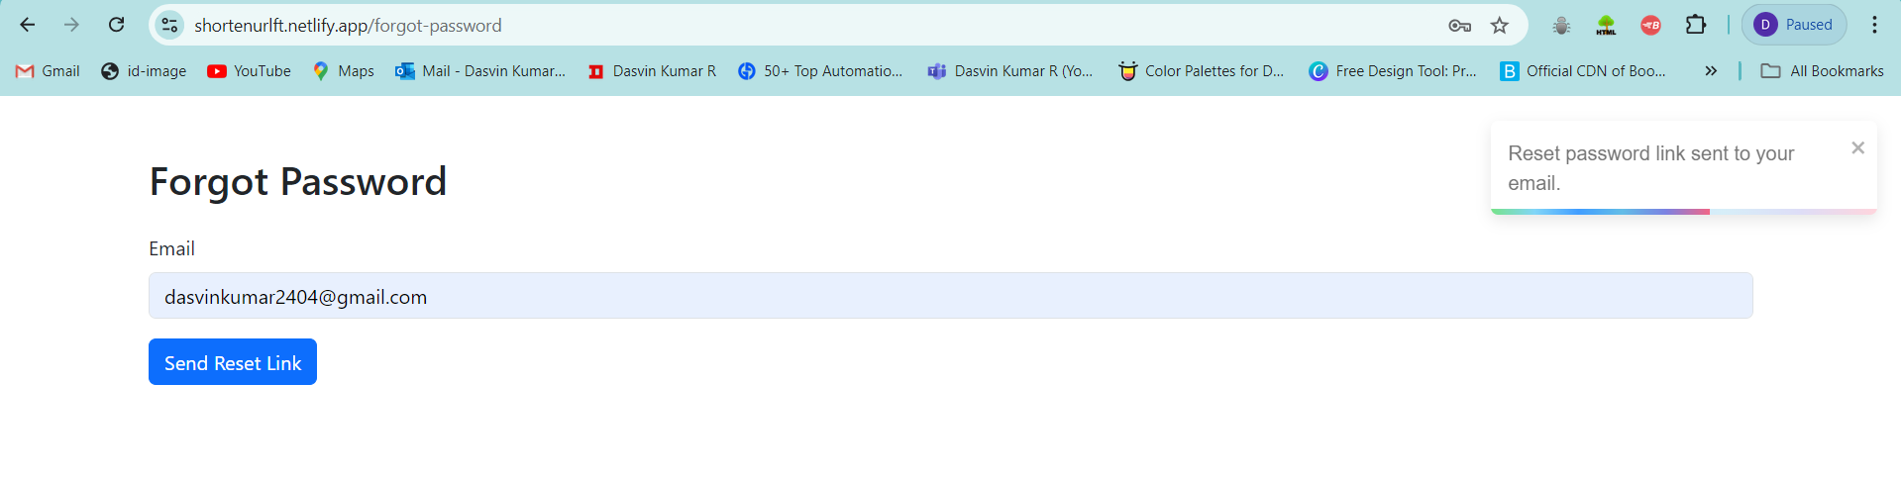

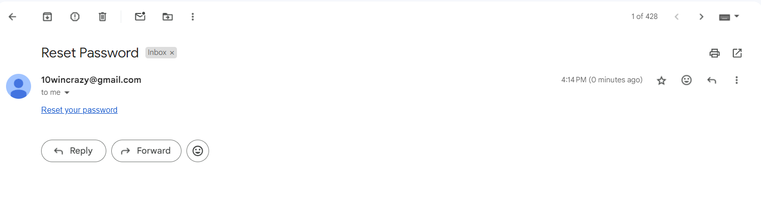

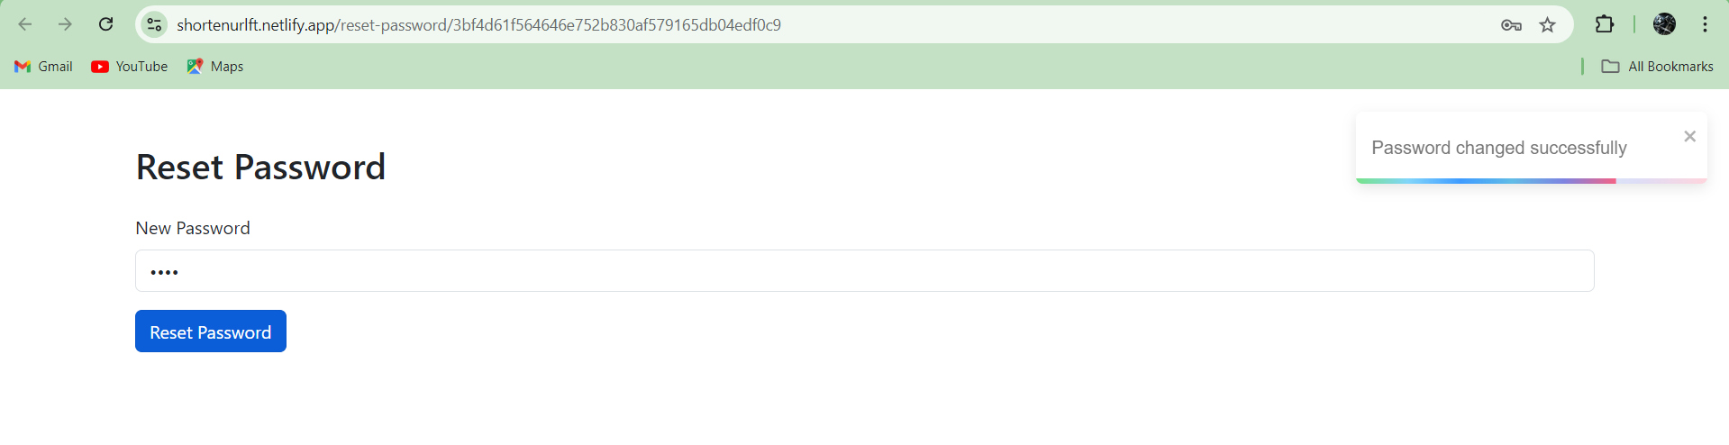

Once password reset done page will redirect to login page

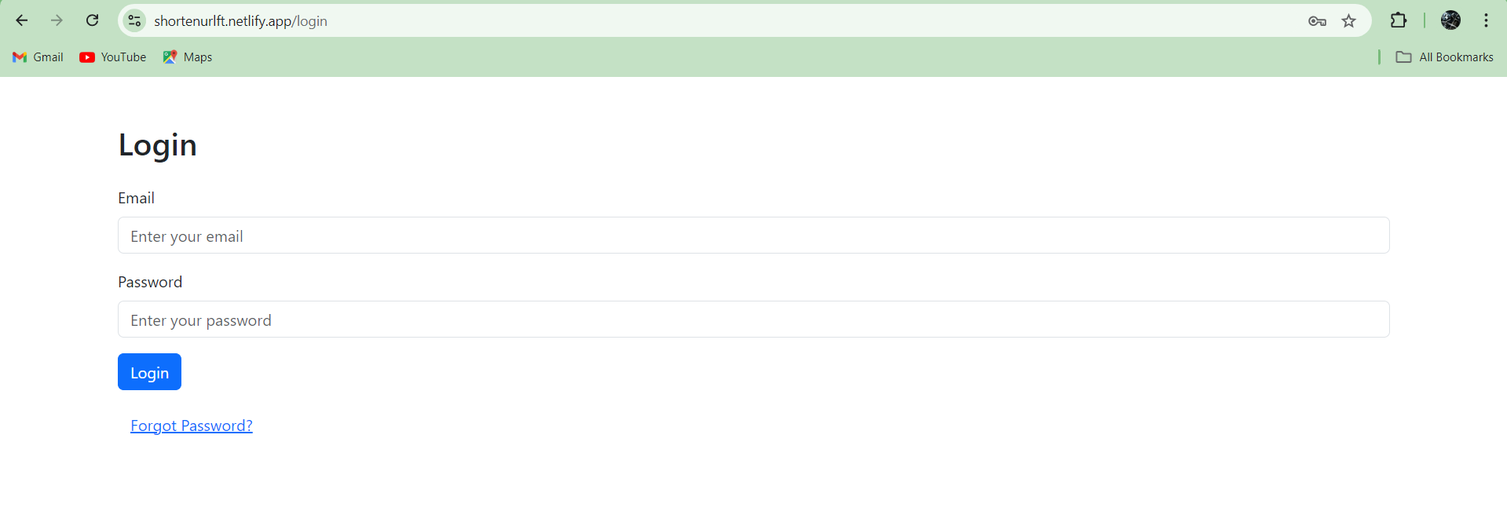

Negative scenario

If user already register

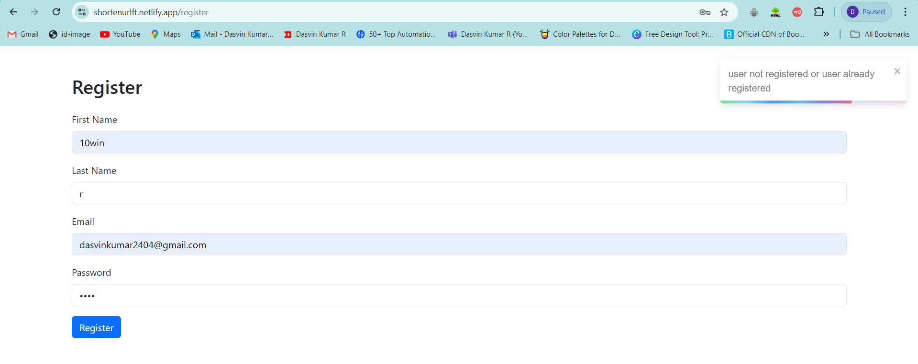

If account not activated or invalid password/userID

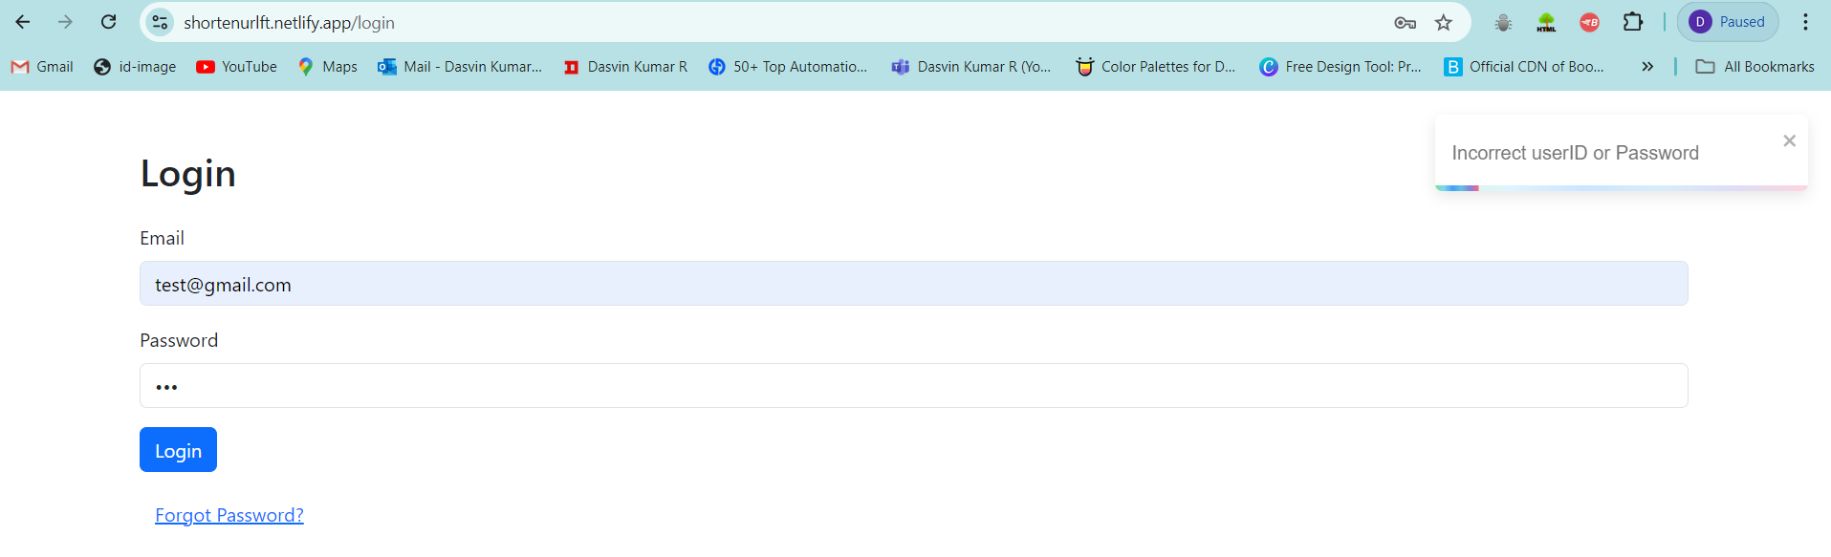

If reset password is not done.

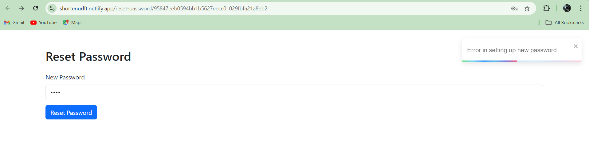

If account activation token invalid